# Introduction to Electrochemical Systems

[1 Introduction to Electrochemical Systems 1](#_Toc28970510)

[1.1 What is electrochemical engineering? 2](#_Toc28970511)

[1.2 What is an electrochemical reaction? 2](#_Toc28970512)

[1.3 The Basics of Electrochemical Cells and Devices 3](#_Toc28970513)

[1.3.1 Basic Layout 3](#_Toc28970514)

[Case Study: The Daniell Cell containing Zinc and Copper Electrodes 3](#_Toc28970515)

[1.3.2 Reduction and Oxidation Reactions 4](#_Toc28970516)

[1.3.3 Galvanic vs Electrolytic Reactions 5](#_Toc28970517)

[1.3.4 Definition of Anode vs Cathode and Positive vs Negative Electrodes 5](#_Toc28970518)

[1.4 Electrode Balances 6](#_Toc28970519)

[1.4.1 The Requirement of Electroneutrality 7](#_Toc28970520)

[1.4.2 Analogy between Electrical and Electrochemical Circuits 8](#_Toc28970521)

[1.5 Applications of Electrochemistry and Electrochemical Engineering 9](#_Toc28970522)

[1.5.1 Electrosynthesis 9](#_Toc28970523)

[Choro-Alkali industry 9](#_Toc28970524)

[Other Chemicals Produced by Electrolysis 9](#_Toc28970525)

[Electrowinning 9](#_Toc28970526)

[Electrorefining 9](#_Toc28970527)

[Ultra-Pure Hydrogen 10](#_Toc28970528)

[1.6 Electric Power Conversion and Storage 10](#_Toc28970529)

[1.6.1 Electrolytic Vs Galvanic Cells 10](#_Toc28970530)

[Primary Batteries 11](#_Toc28970531)

[Secondary Batteries 11](#_Toc28970532)

[Li-Ion Batteries 12](#_Toc28970533)

[Fuel Cells 12](#_Toc28970534)

[Redox Flow Batteries 12](#_Toc28970535)

[1.7 Figures 13](#_Toc28970536)

## What is electrochemical engineering?

“Traditional” chemical engineering includes:

Polymer processing

Biotechnology

Process control

Reactor design

Electrochemical engineering is multidisciplinary and cannot be associated with one single industry. It provides a surprisingly powerful approach for many applications, including:

Synthesis of commodity and specialty chemicals

Coatings and surface finishes

Corrosion prevention

Energy storage and generation

## What is an electrochemical reaction?

Q: What is any chemical reaction?

A: A swapping, stealing, or sharing of electrons

Consider the following reaction:

|  |  |  |
| --- | --- | --- |
|  | $$2HI\left(g\right)→H_{2}\left(g\right)+I_{2}\left(g\right)$$ | (1.1) |

By traditional chemical reaction, this occurs as shown in Figure 1.1.

* $HI$ gas is heated to induce more rapid thermal motion
* This leads to increased collision frequency
* Some collisions lead to an intermediate reaction complex
* The complex dissociates into $H_{2}$ and $I_{2}$

Imagine this reaction occurring at a solid catalyst surface, as shown in Figure 1.2. The reacting species must converge on solid surface, where the chemical reaction can then proceed due their close proximity.

Now, consider reaction (1.1), but carried out electrochemically. This is shown schematically in Figure 1.3.

* Electrochemical reactions require an electrolyte into which species dissolve
* $HI$ splits into ions: $H^{+}$ and $I^{-}$, dissolved in water
* $HI$ no longer need to collide with each other
* Instead, $H^{+}$ and $I^{-}$ need to reach their respective electrodes
* Electrons are stripped from $I^{-}$ to make $I_{2}$, and given to $H^{+}$ to make $H_{2}$
* In other words, the reaction occurs via a different pathway but the results are the same

In actual practice, the electrochemical cell is a bit more complicated, as ‘previewed’ in Figure 1.4.

## The Basics of Electrochemical Cells and Devices

### Basic Layout

An electrochemical cell consists of:

* An electrolyte, often water, but can be organic solvent or some exotic polymer (e.g. Nafion).
* Two electrodes, such as solid slabs of metal or carbon, which must conduct electricity.
* An external circuit, which allows electrons to travel between electrodes.

The ‘typical’ arrangement of an electrochemical cell is shown in Figure 1.5. This cell contains electrodes made of $Zn$ and $Cu$, which combine to make the Daniell Cell, invented in 1836[[1]](#footnote-2). We will use this system as our baseline example when thinking about electrochemical cells, so let’s take a closer look.

#### Case Study: The Daniell Cell containing Zinc and Copper Electrodes

*Note: The following is a rough overview to introduce key concepts, so some details are omitted for clarity.*

The reaction proceeds as follows:

1. The solution initially contains very few $Zn$ ions, so equilibrium dictates that some will dissolve.
   1. $Zn$ metal dissolves into the electrolyte solution as an ion ($Zn^{2+}$)
   2. In the process of becoming an ion it gives up electrons ($2e^{-}$)
   3. These electrons cannot enter the liquid so remain in the metal
2. Electrons ‘dislike’ accumulating in the metal since their negative charges cause them to repel each other.
   1. They will tend to move toward the Copper electrode, causing current to flow
   2. But they do not want to accumulate in the metal at all
3. Similarly, $Zn^{2+}$ ions also dislike accumulating in the solution, since the solution will become increasingly positive

Without some sort of relief from the charge accumulation problem, the cell will stop very quickly. We must provide a place for the electrons to go and remove some positive charges from the electrolyte.

1. This can all be remedied by putting some $Cu^{2+}$ ions in the initial solution
   1. We must actually put $CuSO_{4}→Cu^{2+}+SO_{4}^{2-}$ since we can’t isolate $Cu^{2+}$ for the same charge accumulation reasons mentioned above
2. The $Cu^{2+}$ ions in solution can now accept some of the electrons arriving at the $Cu$ metal electrode
   1. The $Cu^{2+}$ ions will plate onto the electrode as copper metal: $Cu^{2+}+2e^{-}→Cu$
   2. The $SO_{4}^{2-}$ ion does not participate in any reactions, but is needed to balance charges.

Therefore: The counter reaction of $Cu^{2+}$ ions becoming $Cu$ metal remedies all the problems.

* It absorbs the electrons that are shed by the $Zn^{2+}$ ions
* It removes positive charges from the electrolyte to make room for continual $Zn$ dissolution.
* This battery can therefore provide power for an extended period of time. When will it stop?
* The $Zn$ metal is completely dissolved
* The $Cu^{2+}$ in solution is consumed

Note: It is necessary to keep the $Cu^{2+}$ ions away from the $Zn$ metal and vice-versa, so a barrier is placed between the two compartments…in the form of a ‘salt-bridge’ or an anion exchange membrane. This is illustrated in Figure 1.5(right).

### Reduction and Oxidation Reactions

The reaction happening at each electrode is either an oxidation or a reduction.

Consider the plating of copper in the Daniell Cell:

|  |  |  |
| --- | --- | --- |
|  | $$Cu^{2+}+2e^{-}→Cu^{0}$$ | (1.2) |

This is a *reduction* reaction since ${Cu}^{+2}→{Cu}^{0}$, thus the reactant (${Cu}^{2+}$) goes from an oxidation state of +2 to 0.

Alternatively, consider the zinc dissolution reaction:

|  |  |  |
| --- | --- | --- |
|  | $$Zn^{0}→Zn^{2+}+2e^{-}$$ | (1.3) |

This is an oxidation reaction since ${Zn}^{0}→{Zn}^{2+}$, thus the reactant ($Zn$) goes from an oxidation state of 0 to 2+.

Key Points:

* We always have oxidation vs reduction reactions in electrochemistry.
* These occur on opposite electrodes, which we call the anode and the cathode
* Oxidation occurs at the anode, reduction occurs at the cathode
* Electrons appear as reactants at the cathode, and as products at the anode
* There is a simple pneumonic to remember this, which you probably remember from 1st year: “An Ox and a Red Cat”
* This is illustrated pictorially in Figure 1.7
* Also, don’t forget “LEO is a Lion and he GERs”
  + Loses Electrons is Oxidation, Gains Electrons is Reduction

### Galvanic vs Electrolytic Reactions

Just like (some) chemical reactions can proceed in both directions, an electrochemical cell can run both ways. In principle, both directions can be obtained with the same arrangement (but this may not be optimal).

Consider the two cells in Figure 1.6. This shows the Daniell cell operated both directions.

* In one direction the reaction will proceed spontaneously (this occurs in a battery). This is called a “Galvanic Cell”.
* In the reverse direction the reaction must be forced by inputting power. This is called an “Electrolytic Cell”.

### Definition of Anode vs Cathode and Positive vs Negative Electrodes

Depending on whether a given cell is operation galvanically or electrolytically, the role of each electrode changes. The following table illustrates these changes with the Daniell cell as an example:

|  |  |  |
| --- | --- | --- |
| **Electrode / Process** | **Galvanic Cell** | **Electrolytic Cell** |
| **Cathode / Reduction** | + (e.g. $Cu$ in Daniell Cell) | **-** (e.g. $Zn$ in Daniell Cell) |
| **Anode / Oxidation** | **-** (e.g. $Zn$ in Daniell Cell) | + (e.g. $Cu$ in Daniell Cell) |

* It is very important to note that the electrical sign of the metal does NOT change, even though everything else does.
  + This comes from thermodynamics, which is discussed in Chapter 4.
* Basically, the negative metal remains negative and it is the job of the power supply to pump electrons ‘uphill’ into the negative metal during charging.
* Forcing a cell to run backwards is analogous to water in a hydroelectric dam.
  + Water flows downhill to produce electricity for free…
  + but can also be pumped by uphill to store energy at the cost of supplying power to the pump.

## Electrode Balances

One of the principle tools of chemical engineering is the application of balances, which lets us write equations to solve for unknown quantities of interest[[2]](#footnote-3). This applies to electrochemical engineering also. Each electrode can be treated as a ‘black box’ or control volume around which we can perform balances:

* Material (or species) flow in and out of the electrode
* Moles must balance
* Charges must balance
* Charges include ions (e.g. $Fe^{3+}$) and electrons ($3e^{-}$).
  + Electrons are just one more thing that must balance in a reaction
  + They can be treated as a product or a reactant

There is one important feature of electrochemical reactions:

* electrons are confined to conducting materials (metals, carbon)
* while ions are confined to liquids (and some fancy polymer or ceramics)

Consider the simple case of splitting water (which is commonly done to make hydrogen at locations where it cannot be delivered by tanker truck or pipeline), illustrated in Figure 1.8.

What are the analogies to traditional chemical engineering?

* Electrons ‘flow’ through the circuit (note they flow opposite direction to current)
  + Current flows ‘down hill’ from high to low potential
  + Electrons from low (negative) to high (positive or less negative)
* The power supply ‘pumps’ current ‘uphill’ by inducing a voltage difference
  + In a galvanic cell current flows freely (‘downhill’)
  + In an electrolytic cell current is forced to flow ‘uphill’ by a power supply

Given all these things flowing around the cell, proper analysis requires performing balances in the traditional chemical engineering sense. Balance envelopes around each electrode can be drawn as shown in Figure 1.9.

### The Requirement of Electroneutrality

Ionic solutions contain an equal number of positive and negative *charges*. Consider dissolving $NaCl$ in water:

|  |  |  |
| --- | --- | --- |
|  | $$NaCl→Na^{+}+Cl^{-}$$ | (1.4) |

Note that a solid crystal of only $Na^{+}$ does not exist, it must be paired with $Cl^{2}$.

Consider dissolving $CaCl_{2}$:

|  |  |  |
| --- | --- | --- |
|  | $$CaCl_{2}→Ca^{2+}+2Cl^{-}$$ | (1.5) |

The number of moles of each species differs, but the charges still balance. In both cases, a liquid solution of these dissolved salts will be electrically neutral.

Ionic species in liquids are free to move around, so not only is the overall liquid electrically neutral, but it is spatially neutral as well (even down to the atomistic level[[3]](#footnote-4)). Consider the arrangements of ions shown in Figure 1.10. Both arrangements contain an equal number of positive and negative charges, but that on the left is not stable. The “like-charges” will repel each other and distribute themselves in a spatially uniformly manner as shown on the right.

Another aspect of electroneutrality is that reactions on the anode and cathode must produce and consume the same number of charges.

* For every charged species consumed at one electrode, (e.g. $H^{+}$) another needs to take its place at the other electrode
* An equivalent number of electrons must be transferred between electrode 1 and electrode 2
* All positive species move in one direction, while all negative species move the other way.

### Analogy between Electrical and Electrochemical Circuits

An electrochemical cell is an electric circuit just like any other. In fact, many electric circuits have a battery in them, so this is not just analogy but reality too.

Figure 1.11 shows an electrolytic cell as ‘normal’ electric circuit, with the ‘internal’ features of the electrochemical cell hidden and simply called the ‘load’. In this case, the power supply or voltage source must work to pump current through the cell.

Points to note:

* Current must flow through the entire cell, not just electrical connections
* No solid wires connect the electrodes in solution, charge is transported by ions dissolved in solvent (i.e., the electrolyte)

## Applications of Electrochemistry and Electrochemical Engineering

### Electrosynthesis

#### Choro-Alkali industry

* Converts $NaCl$ solutions (essentially seawater) to valuable products
* It produces or synthesizes $Cl_{2}$, $H_{2}$, $NaOH$, bleach, cleansers, disinfectants…
* Creating something ‘valuable’ generally means adding energy:
  + This industry consumes 2% of the electric power generated in the USA

#### Other Chemicals Produced by Electrolysis

Many chemicals *can* be produced by electrolysis, but it is not always the most economical approach.

In other cases, it is either economical, or the only technical way:

* Strong oxidizing agents: e.g. $KMnO_{4}$, $NaClO_{3}$, $F_{2}$, $H_{2}O_{2}$, $O_{3}$
* Metal oxides: e.g. $MnO_{2}$, $Cu_{2}O$
* Metal salts

#### Electrowinning

Electrolysis can be used for the production of *high purity* metals from oxidized forms of the metal. This is one way to ‘refine’ mined ores. (Ore is a basically metal-rich dirt or rock dug from the ground).

* Metal to be plated is dissolved in solution in oxidized form
* Used in the production of $Cu$, $Al$, $Zn$, $Ni$, $Au$, $Ag$, $Cd$, $Co$, $Na$, $Li$, $Mg$, etc
* Can be carried out in aqueous solutions (eg. $Cu$, $Zn$, $Ni$, $Au$, $Ag$, $Cd$, $Co$) or in molten salt baths (eg. $Al$, $Na$, $Li$, $Mg$)

Consider the extremely important case of Aluminum production. It is done using the the Hall-Héroult process shown in Figure 1.13.

* *Continuous process* carried out in a bath of a molten cryolite salt ($Na_{3}AlF_{6}$) bath at temperatures of 940-980°C.
* $Al_{2}O_{3}$ is continually fed by a hopper
* Bottom of carbon anode is continuously consumed, so anode is continuously lowered to keep anode-cathode spacing constant.

#### Electrorefining

Similar to electrowinning, but it’s used to boost medium purity metals (e.g. 99%, perhaps produced by normal smelting methods) into very high purity metals exceeding 99.99% pure. The metal to be purified is the anode, it dissolves, and is re-plated at the anode. The impurities also dissolve, but only the metal plates out.

#### Ultra-Pure Hydrogen

Water is split into $O_{2}$ and $H^{+}$ at the anode, and the $H^{+}$ ions travel to the cathode where they are combined to make $H_{2}$. The general process has been discussed above but is shown in Figure 1.14 more clearly.

* Used to produce very pure $H_{2}$ and $O_{2}$, although usually only $H_{2}$ is recovered
  + Used in fuel cells, hydrogenation of oils, semiconductor manufacturing
* Typically, more expensive than thermal methods of $H_{2}$ production
  + However, no greenhouse gases produced (contrary to steam reforming of methane)
  + Feed stock is easy to find!
* What about electricity?
  + Surplus power from windfarms
* Where to put the hydrogen?
  + Eventually in cars and/or trucks
  + For now, into the natural gas pipelines to burn

Water electrolysis is actually a viable energy storage scheme, since electricity put into the system is ‘stored’ as hydrogen which is a useful (i.e. valuable) product. Hydrogen also has the desirable ability to be stored in tanks, unlike electrons. Figure 1.15 shows a electrolyzer-based energy storage installation in Europe, built by Canada’s own Hydrogenics.

## Electric Power Conversion and Storage

### Electrolytic Vs Galvanic Cells

So far, all the examples we’ve mentioned have received electricity input in order to produce some chemical. It is also possible for electrochemical cells to run the other way.

Electrolytic cell: Utilizes electrical energy to drive an electrochemical reaction

Galvanic cell: Spontaneous reactions generate the flow of current

* Examples:
  + Primary and secondary batteries
  + Fuel cells

Question: Is corrosion an electrolytic or galvanic process? It happens spontaneously, so is galvanic.

Consider the setup shown in Figure 1.16. Connecting two different materials electrically results in a driving force that can enable current to flow. If left alone this will act as a battery, and we can also interfere and ‘recharge’ the battery electrolytically.

We have two shiny new metals, so one of these will become oxidized and act as a fuel, but which one? This question will be answered in detail later in the course. main ingredient in alkaline batteries.

#### Primary Batteries

Act entirely as a galvanic cell in that spontaneous electrode reactions generate electron flow.

A typical primary battery is the well-known Alkaline cell, with popular brands being Duracell and Energizer. The internals of these cells are shown in Figure 1.17.

The anode mix is composed of zinc powder in a gelled aqueous solution of potassium hydroxide. The separator is a cation-selective membrane. The cathode mix is made of manganese dioxide and carbon powders in the same $KOH$ solution.

Why are these batteries garbage after use?

* It is not because the electrochemical reactions are irreversible, but because the ‘fuel’ is a zinc powder that dissolves upon use, and it’s not possible to reform the same powder.

#### Secondary Batteries

Secondary refers to any battery that can be recharged, unlike primary batteries. On discharge act like primary battery converting chemical energy to electrical energy (i.e., a galvanic cell). On charge, power supply used to regenerate energy in battery 🡪 acts as an electrolytic cell

Until the advent of smart-phones and lab-top computers, the most common type of secondary battery was the lead-acid battery. It has been around for 100 years in almost the same form, so it’s very well optimized. It’s main consumer is as a car-starter.

* How is the $Pb$-Acid battery rechargeable but the alkaline isn’t?
  + The $Pb$ remains in solid state…the $PbSO_{4}$ does not dissolve.
  + So aside from some volumetric change, the structure of the electrode remains intact.

#### Li-Ion Batteries

These are the *ultimate* secondary battery because they can be discharged and recharged *many* times with limited degradation.

The anode is graphite with Li+ ions *inserted* between the sheets of graphene. Cathode is some very fancy material with a variety of atoms mixed together, but also provides ‘shelves’ for the $Li$ ions to insert themselves. This mechanism leads to very little electrode changes so no degradation. This is depicted in Figure 1.19

* Common chemistries for the cathode are: $LiCoO_{2}$, $LiFePO_{4}$, $LiNiMnCo$, etc.
* Each has pros and cons. NMC is the leading battery today, but $Co$ is getting hard to find.

#### Fuel Cells

Fuel cells are an interesting class of batteries because they can be ‘refueled’ instead of recharged. The main advantage of this arrangement (compared to Li-ion batteries) is that the fuel tanks can be arbitrarily large compared to the cell. This decouples the

Fuel gas (or liquid) is oxidized galvanically to directly produce electricity. They are effectively a primary battery in which you can continuously feed in reactants to the cell. The gases (e.g. $H_{2}$ and air) flow into the cell, diffuse to reaction sites, form water vapor, then leave. They are amazingly simplistic in principle, but in practice they are quite complicated. They are not in cars (yet) because they are not durable enough to replace internal combustion engines.

* You can burn hydrogen, but oxidizing electrochemically gives 2-3x higher efficiency
  + Electrochemical energy conversion is not subject to the limitations of Carnot efficiency
* $O_{2}$ is everywhere, $H_{2}$ is a simple gas, easy to store and transport.
  + They are part of a hydrogen economy, which many think is inevitable since $H_{2}$ is easy to store.

#### Redox Flow Batteries

Very similar to a fuel cell in design and principle. The main differences is that the ‘spent fuel’ is saved in tanks, and is regenerated by flowing back through the cell in electrolytic mode.

Like the fuel cell, flow batteries have independently scaled storage ($MJ$) and power ($MW$) by changing tank and cell size, respectively. They are also highly durable in principle since all reaction happen in the liquid phase.

* In my lab we design and make electrodes to get maximum performance
* Any guesses as to what sort of properties one might try to optimize/maximum/minimize?
  + Porosity, surface area, pressure drop (known as permeability), electrical conductivity

## Figures

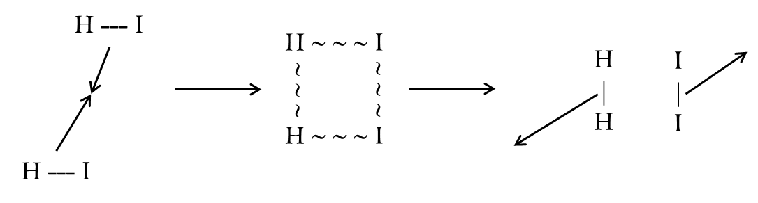

Figure 1.1: Schematic diagram of traditional chemical reaction mechanism

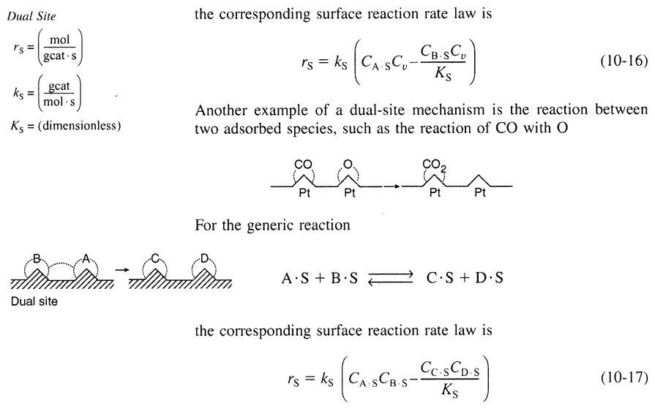

Figure 1.2: $HI$ reacting to produce $H_{2}$ and $I_{2}$ at a catalytic surface (from Fogler). In this case A and B are both $HI$, while C is $H_{2}$ and D is $I_{2}$.

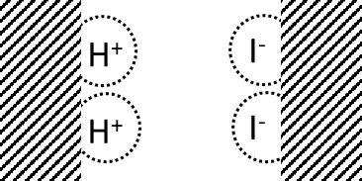

Figure 1.3: $H^{+}$ and $I^{-}$ reacting electrochemically by adsorbing on separate electrodes. Note that electrons cannot hop directly between electrodes but must travel via an external circuit that is not shown.

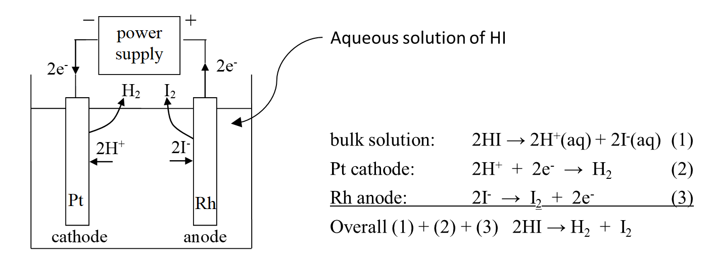

Figure 1.4: Schematic diagram of an electrochemical cell for carrying out reaction (1.4)

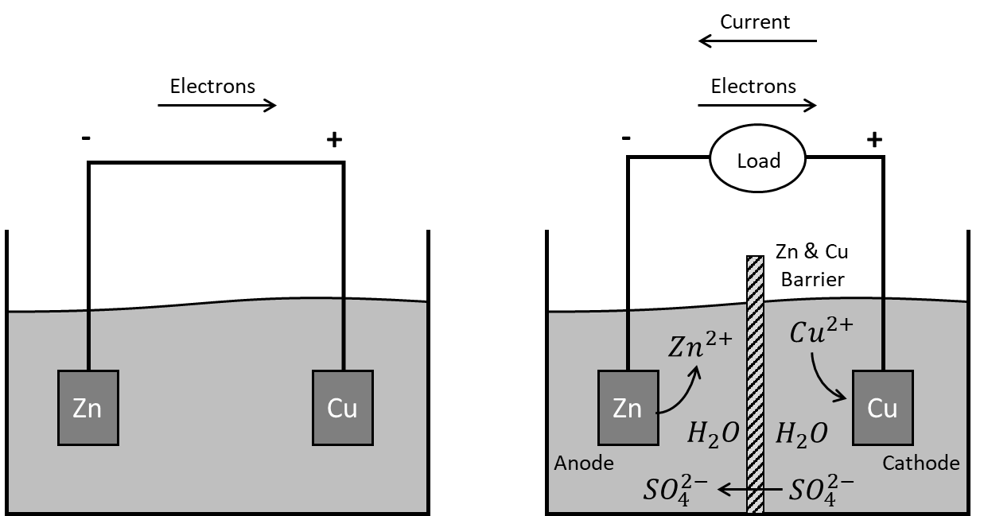

Figure 1.5: Schematic diagram of a basic Daniell cell containing zinc and copper electrodes. Left shows the basic arrangement, while the right shows more details including an anion selective barrier in the middle to prevent $Cu$ and $Zn$ ions from mixing.

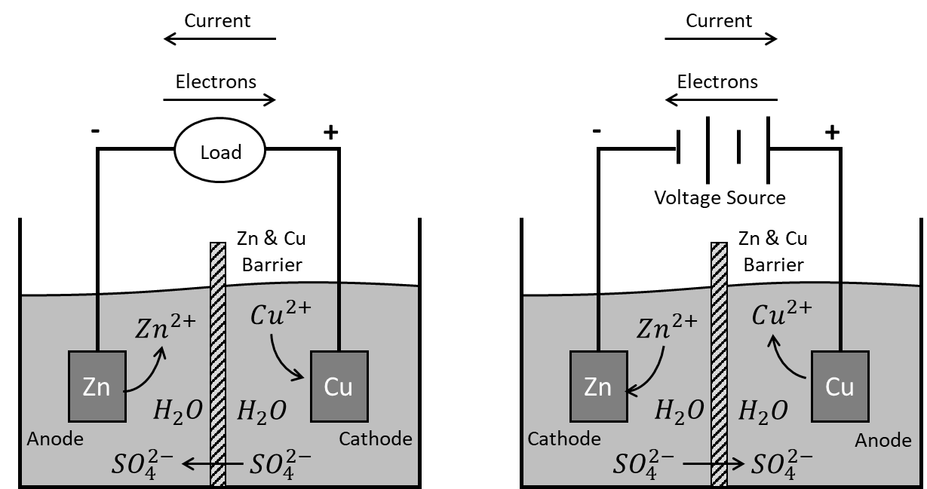

Figure 1.6: Schematic illustration of galvanic vs electrolytic cells. In the electrolytic cell, the direction of all the species is reversed, and the definition of anode and cathode are reversed since the backward reactions are occurring. Note however that the positive and negative signs are not changed. The Zinc metal remains the negative electrode, and the voltage source or “power supply” is able to pump the electrons ‘up-hill’ into this metal.



Figure 1.7: Famous “Red Cat and An Ox” pneumonic device

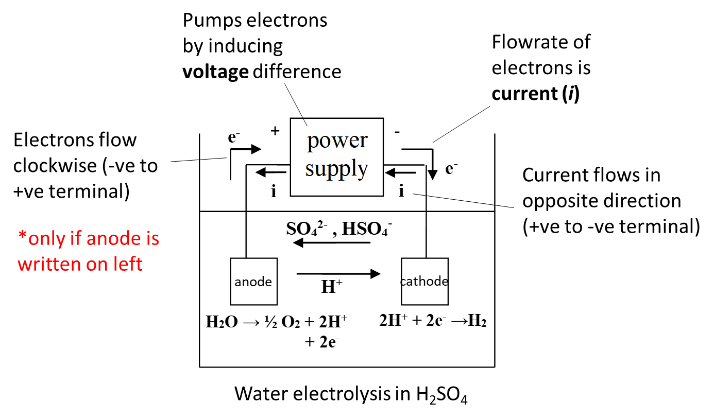

Figure 1.8: Schematic diagram of water electrolysis cell

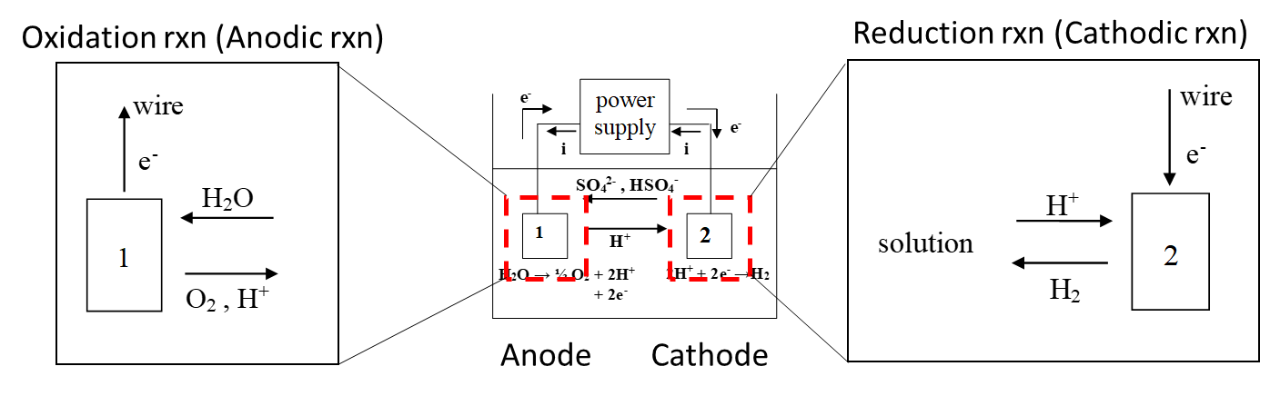

Figure 1.9: Balance envelopes drawn around each electrode

|  |
| --- |
| Figure 1.10: Two possible configurations of ions floating in solution. The configuration on the left is not stable since the “like-charges” will repulse each other, while on the right things are uniformly distributed. |

|  |
| --- |
| Figure 1.11: Representation of an electrochemical cell a ‘normal’ electric circuit. |

|  |
| --- |
| Figure 1.12: Schematic diagram of a chlor-alkali cell with membrane separator. (Courtesy of Wikipedia) |

|  |
| --- |
| D:\temp\DBJWEC001-216\WOST764\E-Book\4\4-1.jpg  Figure 1.13: Schematic diagram of the Hall-Héroult process for electrowinning aluminum from alumina |

|  |
| --- |
| Figure 1.14: Schematic of a water electrolyzer |

|  |
| --- |
| Figure 1.15: Water electrolysis installation in Europe, used to capture renewable energy and produce hydrogen which can be stored. |

|  |
| --- |
| ZnCu_detail.gif  Figure 1.16: An example of a reversible electrochemical cell with zinc and copper electrodes. |

|  |
| --- |
| D:\temp\DBJWEC001-216\WOST764\E-Book\5\5-3.jpg  Figure 1.17: Cross-sectional diagram of an alkaline battery. |

|  |
| --- |
| Figure 1.18: Photo and schematic of a lead-acid battery |

|  |
| --- |
| Landi 2009 - Fig 2.png  Figure 1.19: Schematic diagram of a Li-ion cell, showing the ‘intercalation’ or ‘insertion’ of $Li$ ions into the electrode materials |

|  |
| --- |
| Figure 1.20: Li-ion batteries are powerful and durable enough to work in cars, one of the most energy intensive things we do. Increasing range is an on-going challenge. |

|  |
| --- |
| Figure 1.21: Tesla Mega-battery in the desert of Australia stores energy from wind mills for use when needed by consumers. This install is 100 MW – 130 MJ, so runs for 1 hour at peak output. |

|  |
| --- |
| Figure1-FuelCellConstruction.jpg  Figure 1.22: Internals of a hydrogen fuel cell |

|  |
| --- |
| Figure 1.23: Overview of the hydrogen economy |

|  |
| --- |
| Figure 1.24: An alternative energy storage system using flow batteries. |

|  |
| --- |
| Figure 1.25: The internals of a redox flow battery showing the cross-section of the flow-through electrode made from carbon fibers. |

|  |
| --- |
| Figure 1.26: Tomogram of flow battery electrode (left) and stream-lines of electrolyte flow through the medium, colored by reactant concentration (right). |

1. https://en.wikipedia.org/wiki/Daniell\_cell [↑](#footnote-ref-2)
2. The discipline of chemical engineering can be summed up in the following sentence: “What goes in must come out unless it stays there”. In other words, everything must balance. [↑](#footnote-ref-3)
3. This is not true near charged surfaces, where like-charged ions can accumulate to balance out charges in the solid. [↑](#footnote-ref-4)